Fourier Transform Properties – Gate Function

clear all;

close all;

clc;

% Define parameters

step_omega = 0.01 * pi;

step_size_t = 0.1;

t = -40:step_size_t:40;

omegax = -(1/step_size_t)*pi:step_omega:(1/step_size_t)*pi;

% Pre-allocate Fourier transform matrix and other matrices

exp_omega = zeros(length(omegax), length(t));

x_omega = zeros(1, length(omegax));

% Precompute exponential terms

for ii = 1:length(omegax)

exp_omega(ii,:) = exp(-1j * omegax(ii) .* t);

end

% Define Gate Function (Rectangular Pulse)

width = 1; % Width of the gate

x_t = (t >= -width/2) & (t <= width/2);

subplot(4, 1, 1), plot(t, x_t)

title('Original Signal x(t) - Gate Function')

% Compute Fourier Transform

for ii = 1:length(omegax)

temp = x_t .* exp_omega(ii,:);

x_omega(1,ii) = sum(temp) * step_size_t; % Integral approximation

end

% Plot Magnitude and Phase Spectrum

subplot(4,1,2), plot(omegax, abs(x_omega));

title('Magnitude Spectrum |X(\omega)|')

subplot(4,1,3), plot(omegax, angle(x_omega));

title('Phase Spectrum ∠X(\omega)')

% Reconstruct Signal from Fourier Transform

x_t_reconstructed = zeros(1, length(t));

for ii = 1:length(t)

expo_omega_2(ii,:) = exp(1j * omegax .* t(ii));

temp2 = x_omega .* expo_omega_2(ii,:);

x_t_reconstructed(1,ii) = (1 / (2 * pi)) * sum(temp2) * step_omega;

end

subplot(4,1,4), plot(t, real(x_t_reconstructed));

title('Reconstructed Signal from X(\omega)')

% Property 1: Shifting Property

shift = 10; % Example shift amount

x_t_shifted = (t - shift >= -width/2) & (t - shift <= width/2);

figure;

subplot(3,1,1), plot(t, x_t_shifted);

title(['Shifted Signal x(t - ', num2str(shift), ')']);

x_omega_shifted = zeros(1, length(omegax));

for ii = 1:length(omegax)

temp_shift = x_t_shifted .* exp_omega(ii,:);

x_omega_shifted(1,ii) = sum(temp_shift) * step_size_t;

end

subplot(3,1,2), plot(omegax, abs(x_omega_shifted));

title('Magnitude Spectrum |X(\omega)| after Shifting')

% Phase spectrum for shifted signal

subplot(3,1,3), plot(omegax, angle(x_omega_shifted));

title('Phase Spectrum ∠X(\omega) after Shifting')

% Property 2: Scaling Property

scale_factor = 2; % Example scale factor

x_t_scaled = ((t / scale_factor) >= -width/2) & ((t / scale_factor) <= width/2);

figure;

subplot(3,1,1), plot(t, x_t_scaled);

title(['Scaled Signal x(at) with a = ', num2str(scale_factor)])

x_omega_scaled = zeros(1, length(omegax));

for ii = 1:length(omegax)

temp_scale = x_t_scaled .* exp_omega(ii,:);

x_omega_scaled(1,ii) = sum(temp_scale) * step_size_t;

end

subplot(3,1,2), plot(omegax, abs(x_omega_scaled));

title('Magnitude Spectrum |X(\omega)| after Scaling')

% Phase spectrum for scaled signal

subplot(3,1,3), plot(omegax, angle(x_omega_scaled));

title('Phase Spectrum ∠X(\omega) after Scaling')

% Property 3: Parseval's Theorem

energy_time_domain = sum(abs(x_t).^2) * step_size_t;

energy_freq_domain = sum(abs(x_omega).^2) * step_omega / (2 * pi);

fprintf('Energy in time domain: %.4f\n', energy_time_domain);

fprintf('Energy in frequency domain: %.4f\n', energy_freq_domain);

% Check if Parseval's theorem holds

if abs(energy_time_domain - energy_freq_domain) < 1e-3

disp('Parseval''s theorem is verified: Energy in time and frequency domains are equal.');

else

disp('Parseval''s theorem is not verified: Energy in time and frequency domains differ.');

end

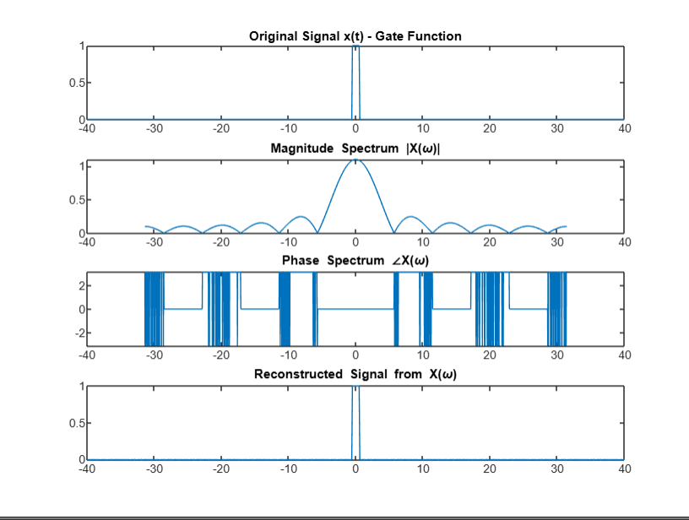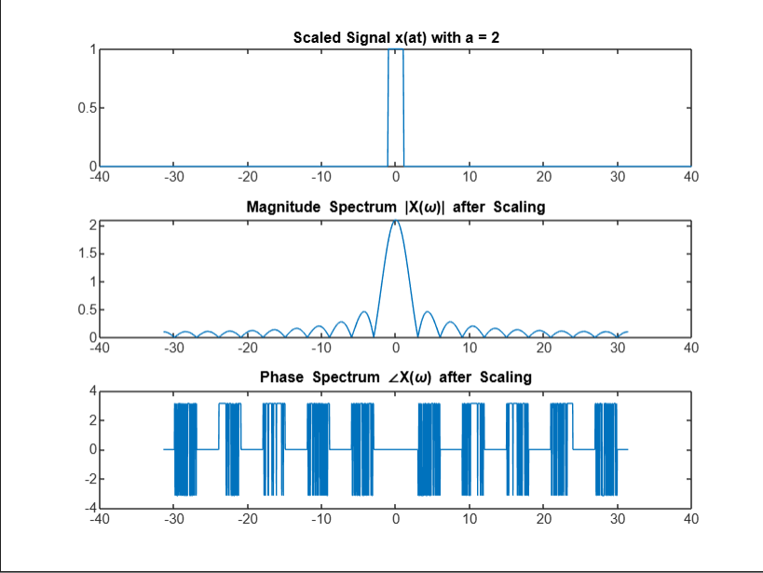

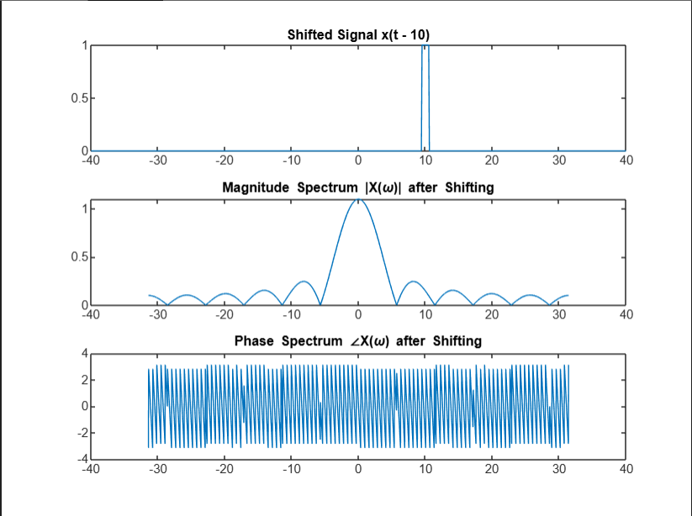

Fourier Transform Properties – Sinc Function

clear all;

close all;

clc;

% Define parameters

step_omega = 0.01 * pi;

step_size_t = 0.1;

t = -40:step_size_t:40;

omegax = -(1/step_size_t) * pi : step_omega : (1/step_size_t) * pi;

% Pre-allocate Fourier transform matrix and other matrices

exp_omega = zeros(length(omegax), length(t));

x_omega = zeros(1, length(omegax));

% Precompute exponential terms for Fourier transform

for ii = 1:length(omegax)

exp_omega(ii,:) = exp(-1j * omegax(ii) .* t);

end

% Define Sinc Function

for ii = 1:length(t)

if t(ii) == 0

x_t(ii) = 1; % sinc(0) = 1

else

x_t(ii) = sin(pi * t(ii)) / (pi * t(ii)); % Sinc function

end

end

subplot(4, 1, 1), plot(t, x_t);

title('Original Signal x(t) - Sinc Function');

% Compute Fourier Transform of Sinc Function

for ii = 1:length(omegax)

temp = x_t .* exp_omega(ii,:);

x_omega(1, ii) = sum(temp) * step_size_t; % Approximate integral

end

% Plot Magnitude and Phase Spectrum for Sinc Function

subplot(4,1,2), plot(omegax, abs(x_omega));

title('Magnitude Spectrum |X(\omega)| of Sinc Function');

subplot(4,1,3), plot(omegax, angle(x_omega));

title('Phase Spectrum ∠X(\omega) of Sinc Function');

% Reconstruct Signal from Fourier Transform

x_t_reconstructed = zeros(1, length(t));

for ii = 1:length(t)

temp2 = x_omega .* exp(1j * omegax * t(ii));

x_t_reconstructed(ii) = (1 / (2 * pi)) * sum(temp2) * step_omega;

end

subplot(4,1,4), plot(t, real(x_t_reconstructed));

title('Reconstructed Signal from X(\omega)');

% Property 1: Shifting Property

shift = 10; % Example shift amount

x_t_shifted = zeros(1, length(t));

for ii = 1:length(t)

if t(ii) - shift == 0

x_t_shifted(ii) = 1; % sinc(0) = 1

else

x_t_shifted(ii) = sin(pi * (t(ii) - shift)) / (pi * (t(ii) - shift));

end

end

figure;

subplot(3,1,1), plot(t, x_t_shifted);

title(['Shifted Signal x(t - ', num2str(shift), ') - Sinc Function']);

x_omega_shifted = zeros(1, length(omegax));

for ii = 1:length(omegax)

temp_shift = x_t_shifted .* exp_omega(ii,:);

x_omega_shifted(ii) = sum(temp_shift) * step_size_t;

end

subplot(3,1,2), plot(omegax, abs(x_omega_shifted));

title('Magnitude Spectrum |X(\omega)| after Shifting');

% Phase spectrum for shifted signal

subplot(3,1,3), plot(omegax, angle(x_omega_shifted));

title('Phase Spectrum ∠X(\omega) after Shifting');

% Property 2: Scaling Property

scale_factor = 2; % Example scale factor

x_t_scaled = zeros(1, length(t));

for ii = 1:length(t)

if (t(ii) / scale_factor) == 0

x_t_scaled(ii) = 1; % sinc(0) = 1

else

x_t_scaled(ii) = sin(pi * (t(ii) / scale_factor)) / (pi * (t(ii) / scale_factor));

end

end

figure;

subplot(3,1,1), plot(t, x_t_scaled);

title(['Scaled Signal x(at) with a = ', num2str(scale_factor), ' - Sinc Function']);

x_omega_scaled = zeros(1, length(omegax));

for ii = 1:length(omegax)

temp_scale = x_t_scaled .* exp_omega(ii,:);

x_omega_scaled(ii) = sum(temp_scale) * step_size_t;

end

subplot(3,1,2), plot(omegax, abs(x_omega_scaled));

title('Magnitude Spectrum |X(\omega)| after Scaling');

% Phase spectrum for scaled signal

subplot(3,1,3), plot(omegax, angle(x_omega_scaled));

title('Phase Spectrum ∠X(\omega) after Scaling');

% Property 3: Parseval's Theorem for Sinc Function

energy_time_domain = sum(abs(x_t).^2) * step_size_t;

energy_freq_domain = sum(abs(x_omega).^2) * step_omega / (2 * pi);

fprintf('Energy in time domain: %.4f\n', energy_time_domain);

fprintf('Energy in frequency domain: %.4f\n', energy_freq_domain);

% Check if Parseval's theorem holds

if abs(energy_time_domain - energy_freq_domain) < 1e-3

disp('Parseval''s theorem is verified: Energy in time and frequency domains are equal.');

else

disp('Parseval''s theorem is not verified: Energy in time and frequency domains differ.');

end

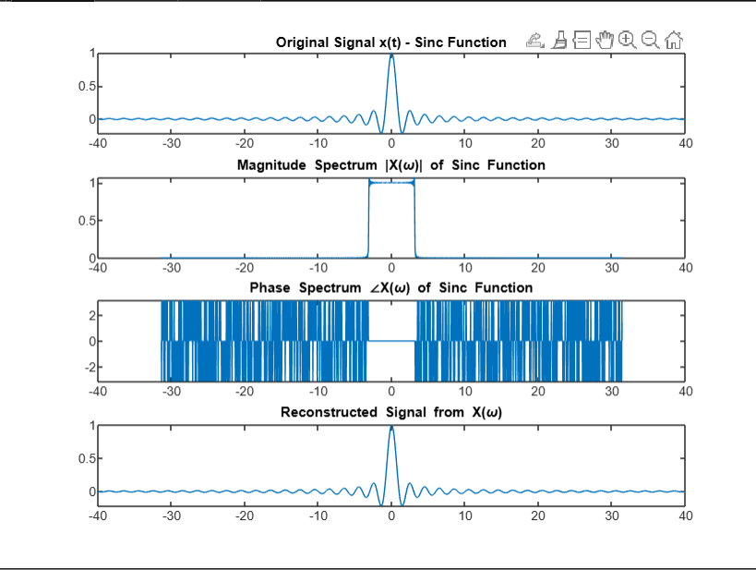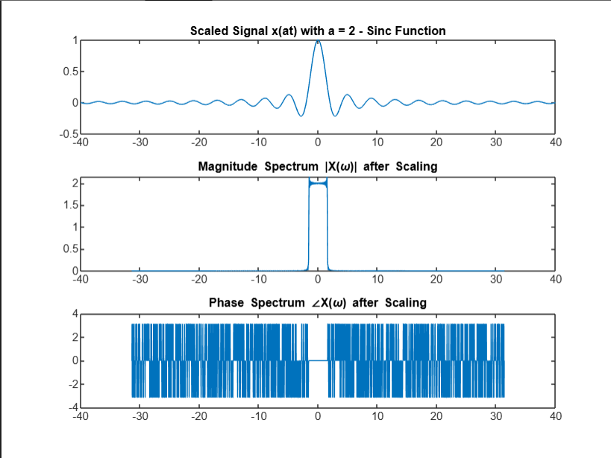

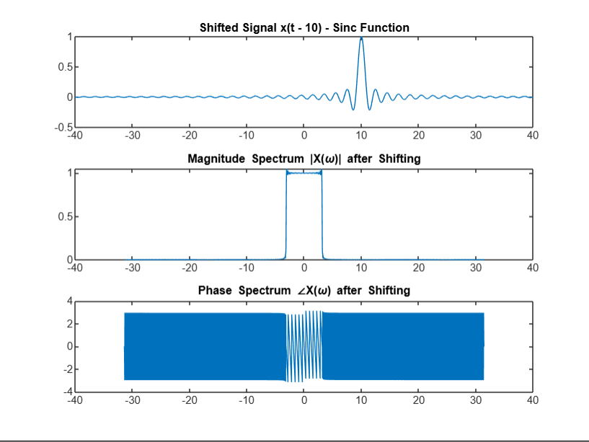

Fourier Transform Properties – Unit Step Function

clear all;

close all;

clc;

% Define parameters

step_omega = 0.01 * pi;

step_size_t = 0.1;

t = -40:step_size_t:40;

omegax = -(1/step_size_t)*pi : step_omega : (1/step_size_t)*pi;

% Pre-allocate Fourier transform matrix and other matrices

exp_omega = zeros(length(omegax), length(t));

x_omega = zeros(1, length(omegax));

% Precompute exponential terms

for ii = 1:length(omegax)

exp_omega(ii,:) = exp(-1j * omegax(ii) .* t);

end

% Define Unit Step Function

x_t = (t >= 0); % Unit step function u(t)

subplot(4, 1, 1), plot(t, x_t)

title('Original Signal x(t) - Unit Step Function')

% Compute Fourier Transform of Unit Step Function

for ii = 1:length(omegax)

temp = x_t .* exp_omega(ii,:);

x_omega(1,ii) = sum(temp) * step_size_t; % Integral approximation

end

% Plot Magnitude and Phase Spectrum

subplot(4,1,2), plot(omegax, abs(x_omega));

title('Magnitude Spectrum |X(\omega)|')

subplot(4,1,3), plot(omegax, angle(x_omega));

title('Phase Spectrum ∠X(\omega)')

% Reconstruct Signal from Fourier Transform

x_t_reconstructed = zeros(1, length(t));

for ii = 1:length(t)

expo_omega_2(ii,:) = exp(1j * omegax .* t(ii));

temp2 = x_omega .* expo_omega_2(ii,:);

x_t_reconstructed(1,ii) = (1 / (2 * pi)) * sum(temp2) * step_omega;

end

subplot(4,1,4), plot(t, real(x_t_reconstructed));

title('Reconstructed Signal from X(\omega)')

% Property 1: Shifting Property

shift = 10; % Example shift amount

x_t_shifted = (t - shift >= 0); % Shifted unit step function u(t - shift)

figure;

subplot(3,1,1), plot(t, x_t_shifted);

title(['Shifted Signal x(t - ', num2str(shift), ') - Unit Step Function']);

x_omega_shifted = zeros(1, length(omegax));

for ii = 1:length(omegax)

temp_shift = x_t_shifted .* exp_omega(ii,:);

x_omega_shifted(1,ii) = sum(temp_shift) * step_size_t;

end

subplot(3,1,2), plot(omegax, abs(x_omega_shifted));

title('Magnitude Spectrum |X(\omega)| after Shifting')

% Phase spectrum for shifted signal

subplot(3,1,3), plot(omegax, angle(x_omega_shifted));

title('Phase Spectrum ∠X(\omega) after Shifting')

% Property 2: Scaling Property

scale_factor = 2; % Example scale factor

x_t_scaled = ((t / scale_factor) >= 0); % Scaled unit step function u(at)

figure;

subplot(3,1,1), plot(t, x_t_scaled);

title(['Scaled Signal x(at) with a = ', num2str(scale_factor)])

x_omega_scaled = zeros(1, length(omegax));

for ii = 1:length(omegax)

temp_scale = x_t_scaled .* exp_omega(ii,:);

x_omega_scaled(1,ii) = sum(temp_scale) * step_size_t;

end

subplot(3,1,2), plot(omegax, abs(x_omega_scaled));

title('Magnitude Spectrum |X(\omega)| after Scaling')

% Phase spectrum for scaled signal

subplot(3,1,3), plot(omegax, angle(x_omega_scaled));

title('Phase Spectrum ∠X(\omega) after Scaling')

% Property 3: Parseval's Theorem

energy_time_domain = sum(abs(x_t).^2) * step_size_t;

energy_freq_domain = sum(abs(x_omega).^2) * step_omega / (2 * pi);

fprintf('Energy in time domain: %.4f\n', energy_time_domain);

fprintf('Energy in frequency domain: %.4f\n', energy_freq_domain);

% Check if Parseval's theorem holds

if abs(energy_time_domain - energy_freq_domain) < 1e-3

disp('Parseval''s theorem is verified: Energy in time and frequency domains are equal.');

else

disp('Parseval''s theorem is not verified: Energy in time and frequency domains differ.');

end

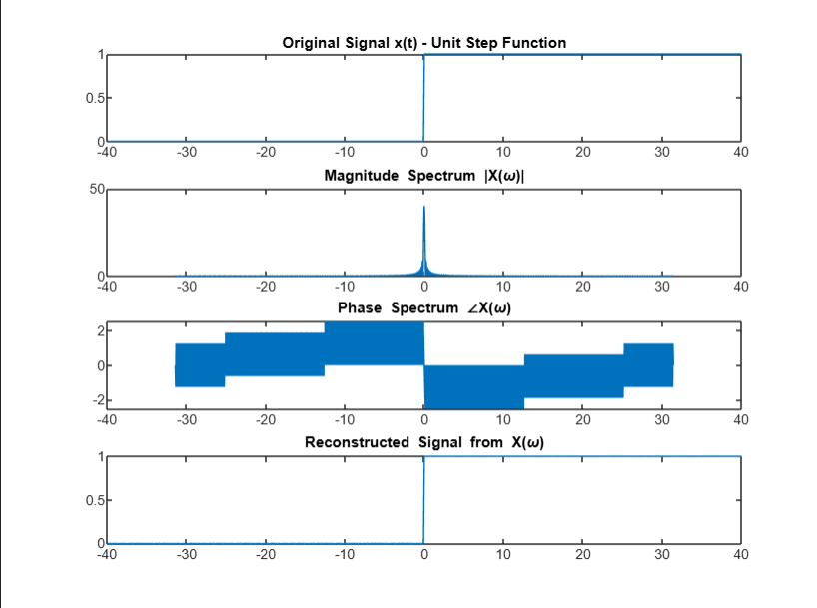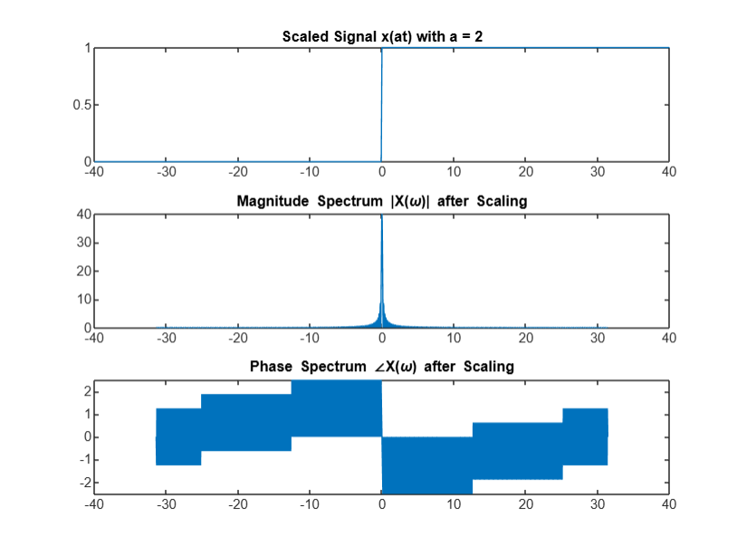

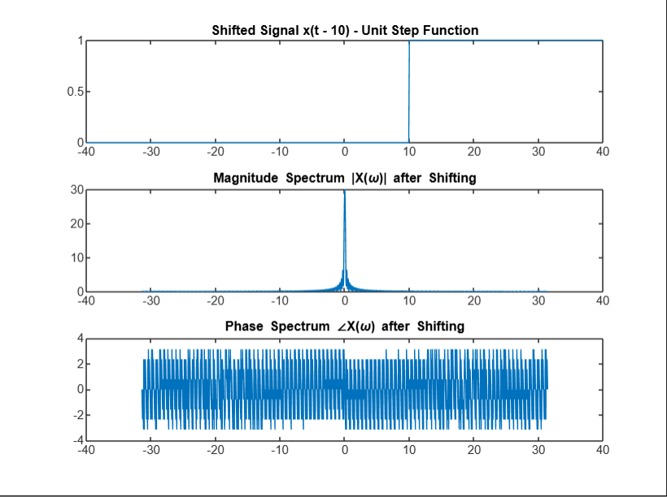

Fourier Transform Properties – Signum Function

clear all;

close all;

clc;

% Define parameters

step_omega = 0.01 * pi;

step_size_t = 0.1;

t = -40:step_size_t:40;

omegax = -(1/step_size_t) * pi : step_omega : (1/step_size_t) * pi;

% Pre-allocate Fourier transform matrix and other matrices

exp_omega = zeros(length(omegax), length(t));

x_omega = zeros(1, length(omegax));

% Precompute exponential terms for Fourier transform

for ii = 1:length(omegax)

exp_omega(ii,:) = exp(-1j * omegax(ii) .* t);

end

% Define Signum Function

v_t = zeros(1, length(t));

for ii = 1:length(t)

if t(ii) < 0

v_t(ii) = -1; % Negative values

elseif t(ii) == 0

v_t(ii) = 0; % Zero

else

v_t(ii) = 1; % Positive values

end

end

subplot(4, 1, 1), plot(t, v_t);

title('Original Signal v(t) - Signum Function');

% Compute Fourier Transform of Signum Function

for ii = 1:length(omegax)

temp = v_t .* exp_omega(ii,:);

x_omega(1, ii) = sum(temp) * step_size_t; % Approximate integral

end

% Plot Magnitude and Phase Spectrum

subplot(4,1,2), plot(omegax, abs(x_omega));

title('Magnitude Spectrum |X(\omega)|');

subplot(4,1,3), plot(omegax, angle(x_omega));

title('Phase Spectrum ∠X(\omega)');

% Reconstruct Signal from Fourier Transform

v_t_reconstructed = zeros(1, length(t));

for ii = 1:length(t)

temp2 = x_omega .* exp(1j * omegax * t(ii));

v_t_reconstructed(ii) = (1 / (2 * pi)) * sum(temp2) * step_omega;

end

subplot(4,1,4), plot(t, real(v_t_reconstructed));

title('Reconstructed Signal from X(\omega)');

% Property 1: Shifting Property

shift = 10; % Example shift amount

v_t_shifted = zeros(1, length(t));

for ii = 1:length(t)

if t(ii) - shift < 0

v_t_shifted(ii) = -1;

elseif t(ii) - shift == 0

v_t_shifted(ii) = 0;

else

v_t_shifted(ii) = 1;

end

end

figure;

subplot(3,1,1), plot(t, v_t_shifted);

title(['Shifted Signal v(t - ', num2str(shift), ')']);

x_omega_shifted = zeros(1, length(omegax));

for ii = 1:length(omegax)

temp_shift = v_t_shifted .* exp_omega(ii,:);

x_omega_shifted(ii) = sum(temp_shift) * step_size_t;

end

subplot(3,1,2), plot(omegax, abs(x_omega_shifted));

title('Magnitude Spectrum |X(\omega)| after Shifting');

% Phase spectrum for shifted signal

subplot(3,1,3), plot(omegax, angle(x_omega_shifted));

title('Phase Spectrum ∠X(\omega) after Shifting');

% Property 2: Scaling Property

scale_factor = 2; % Example scale factor

v_t_scaled = zeros(1, length(t));

for ii = 1:length(t)

if (t(ii) / scale_factor) < 0

v_t_scaled(ii) = -1;

elseif (t(ii) / scale_factor) == 0

v_t_scaled(ii) = 0;

else

v_t_scaled(ii) = 1;

end

end

figure;

subplot(3,1,1), plot(t, v_t_scaled);

title(['Scaled Signal v(at) with a = ', num2str(scale_factor)]);

x_omega_scaled = zeros(1, length(omegax));

for ii = 1:length(omegax)

temp_scale = v_t_scaled .* exp_omega(ii,:);

x_omega_scaled(ii) = sum(temp_scale) * step_size_t;

end

subplot(3,1,2), plot(omegax, abs(x_omega_scaled));

title('Magnitude Spectrum |X(\omega)| after Scaling');

% Phase spectrum for scaled signal

subplot(3,1,3), plot(omegax, angle(x_omega_scaled));

title('Phase Spectrum ∠X(\omega) after Scaling');

% Property 3: Parseval's Theorem

energy_time_domain = sum(abs(v_t).^2) * step_size_t;

energy_freq_domain = sum(abs(x_omega).^2) * step_omega / (2 * pi);

fprintf('Energy in time domain: %.4f\n', energy_time_domain);

fprintf('Energy in frequency domain: %.4f\n', energy_freq_domain);

% Check if Parseval's theorem holds

if abs(energy_time_domain - energy_freq_domain) < 1e-3

disp('Parseval''s theorem is verified: Energy in time and frequency domains are equal.');

else

disp('Parseval''s theorem is not verified: Energy in time and frequency domains differ.');

end

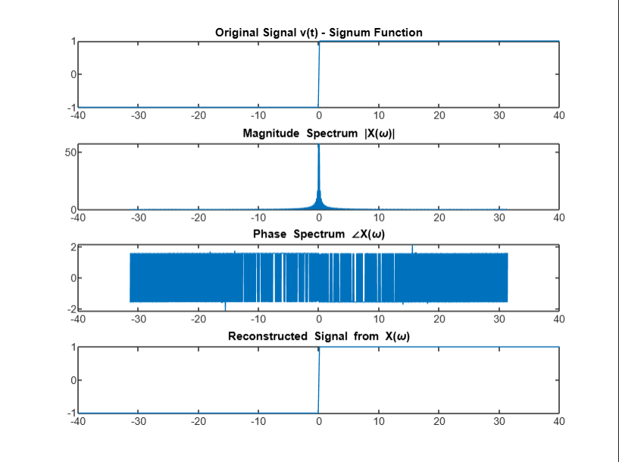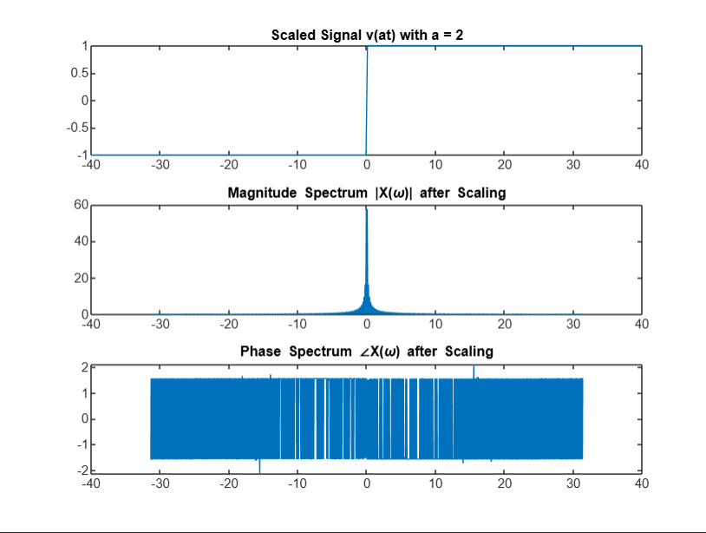

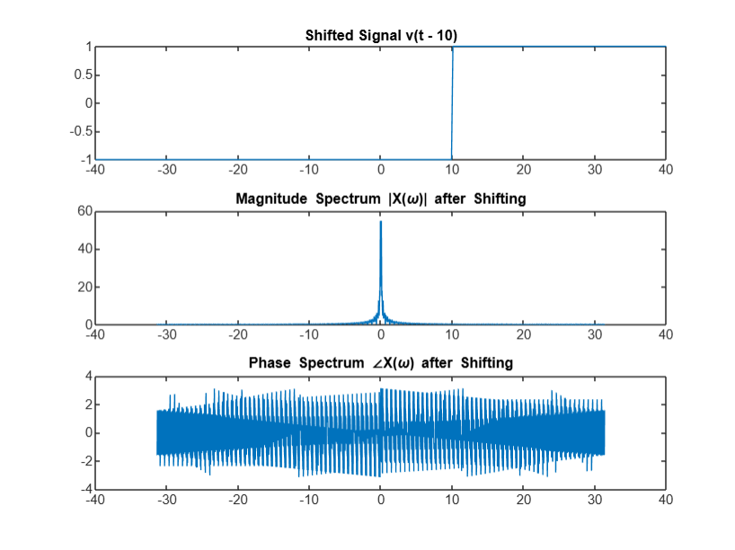

Laplace Transform :

clc;

clear all;

close all;

% Define parameters

step_omega = 0.01 * pi;

step_size_t = 0.1;

t = -40:step_size_t:40;

length_t = length(t);

omegax = -(1 / step_size_t) * pi : step_omega : (1 / step_size_t) * pi;

length_omega = length(omegax);

sigmax = -5:0.01:5;

% Create mesh grid for plotting

[X, Y] = meshgrid(sigmax, omegax);

% Precompute exponential terms for Fourier transform

expo_omega = zeros(length_omega, length_t);

for ii = 1:length_omega

expo_omega(ii, :) = exp(-1j * omegax(ii) .* t);

end

expo_sigma = zeros(length(sigmax), length_t);

for ii = 1:length(sigmax)

expo_sigma(ii, :) = exp(-1 * sigmax(ii) .* t);

end

% Select Signal: Uncomment only one section at a time

% % Impulse Signal

% x_t = zeros(1, length_t);

% x_t(t == 0) = 1 / step_size_t;

% % Unit Step

% x_t = zeros(1, length_t);

% x_t(t >= 0) = 1;

% % Signum Function

% x_t = zeros(1, length_t);

% x_t(t < 0) = -1;

% x_t(t > 0) = 1;

% % Decaying Exponential

% x_t = zeros(1, length_t);

% x_t(t >= 0) = 3 * exp(-2 * t(t >= 0));

% % Double-Sided Exponential

% x_t = zeros(1, length_t);

% x_t(t < 0) = 3 * exp(2 * t(t < 0));

% x_t(t >= 0) = 3 * exp(-2 * t(t >= 0));

% % Sinusoid

%x_t = sin(2 * pi * (1 / (2 * step_size_t)) * 0.5 .* t);

%% Cosine

%x_t = cos(2 * pi * (1 / (2 * step_size_t)) * 0.5 .* t);

%% Sinc Function

%x_t = sinc(t);

%% Gate Function

%x_t = (t >= -0.5) & (t <= 0.5);

% Plot the selected signal

% subplot(2, 1, 1);

% plot(t, x_t);

% title('Selected Signal x(t)');

% xlabel('Time t');

% ylabel('Amplitude');

% Compute Laplace Transform with sigma and j*omega

X_s = zeros(length_omega, length(sigmax));

for ii = 1:length(sigmax)

temp = x_t.* expo_sigma(ii, :);

for jj = 1:length_omega

temp1 = temp .* expo_omega(jj, :);

X_s(jj, ii) = sum(temp1) * step_size_t; % Approximate integral

end

end

% Plot Laplace Transform magnitude in dB

subplot(2, 1, 2);

surf(X, Y, 10 * log10(abs(X_s)), 'EdgeColor', 'none');

xlabel('Sigma');

ylabel('j\omega');

zlabel('10*log_{10}|X(s)|');

title('Magnitude Spectrum of Laplace Transform');

colorbar;

Impulse Function

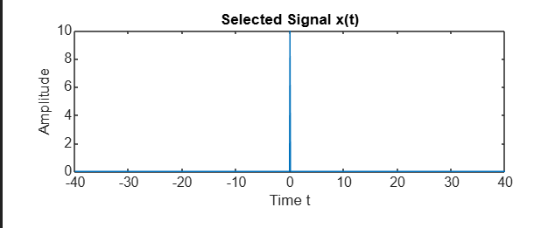

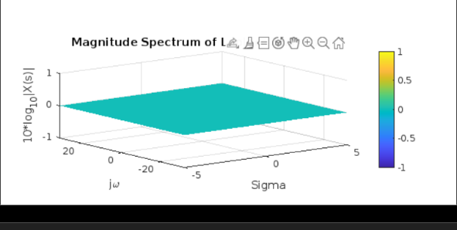

Unit Step Function

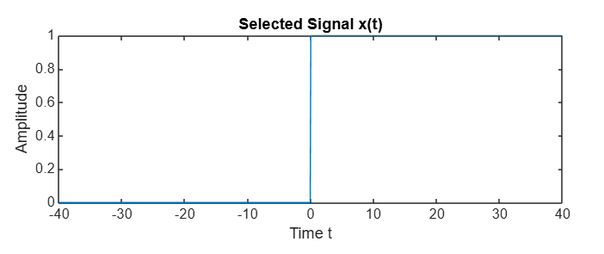

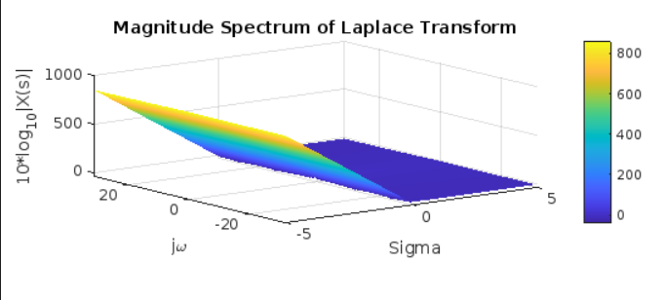

Signum Function

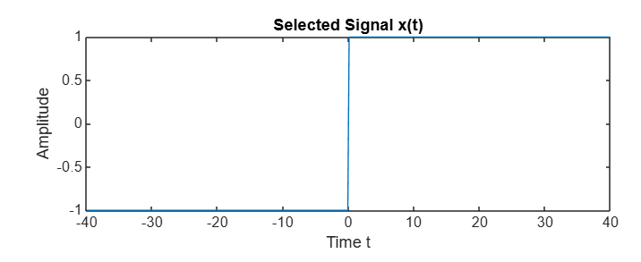

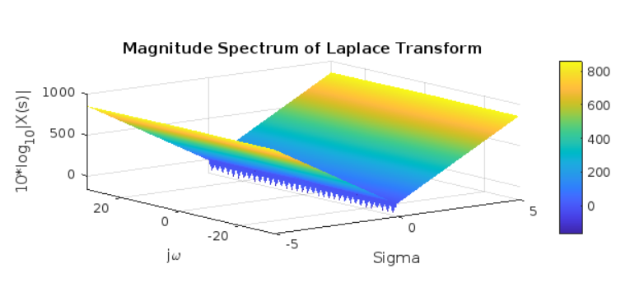

Exponential Decay Function

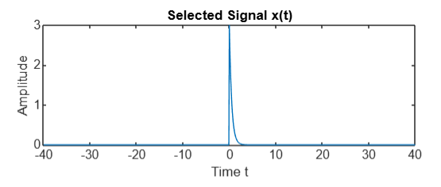

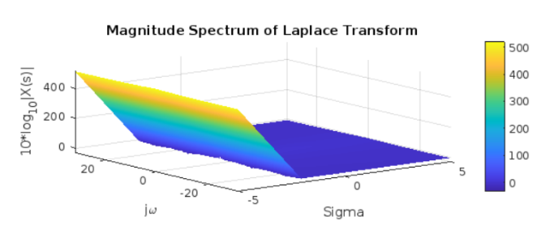

Double Exponential Decay Function

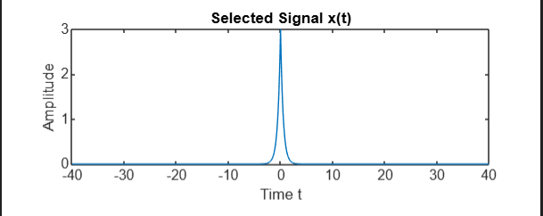

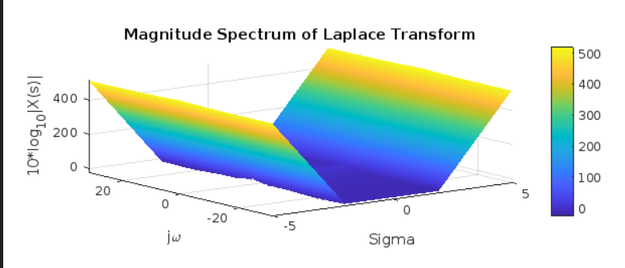

Sine Function

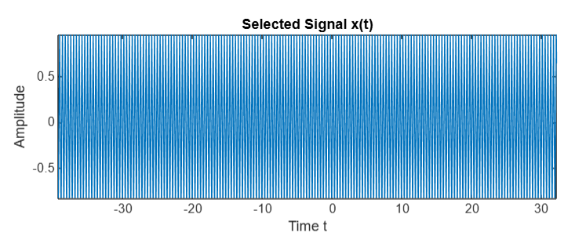

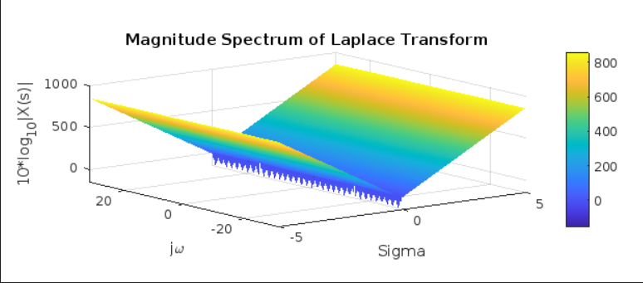

Cosine Function

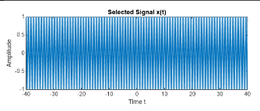

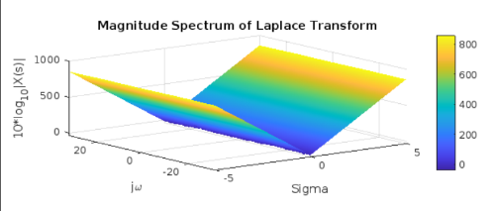

Sinc Function

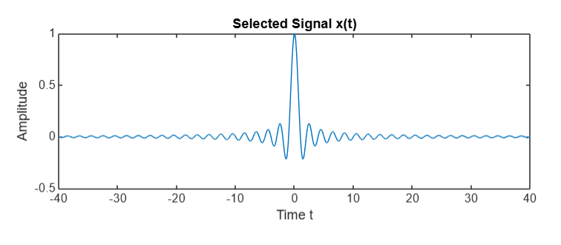

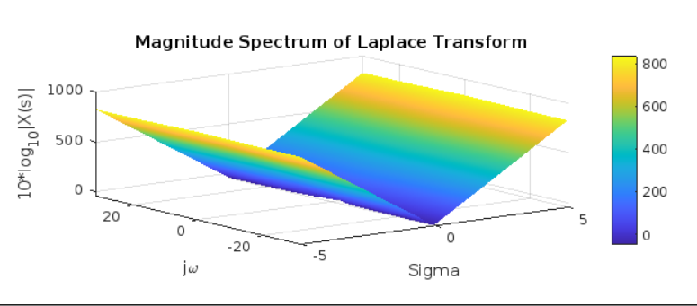

Gate Function

